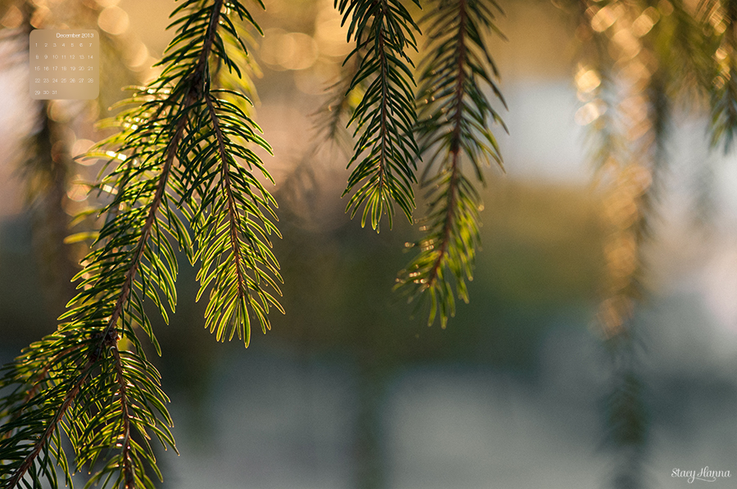

**Artists of the Month: DECEMBER**

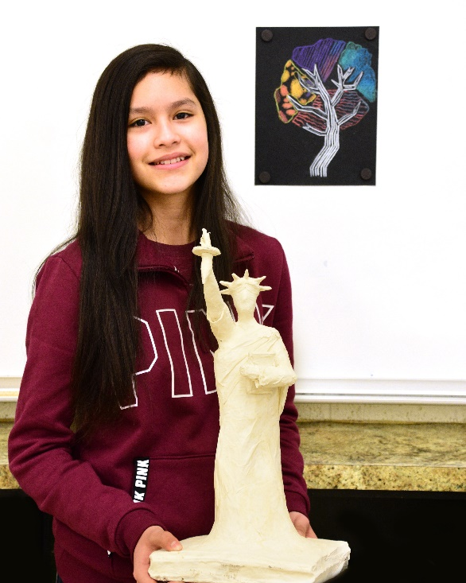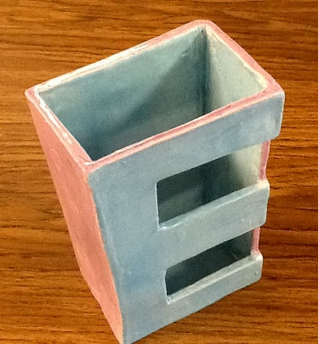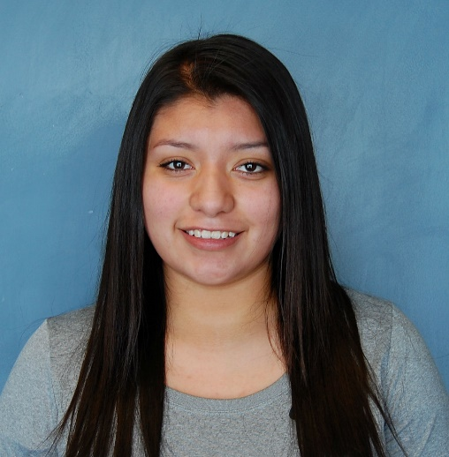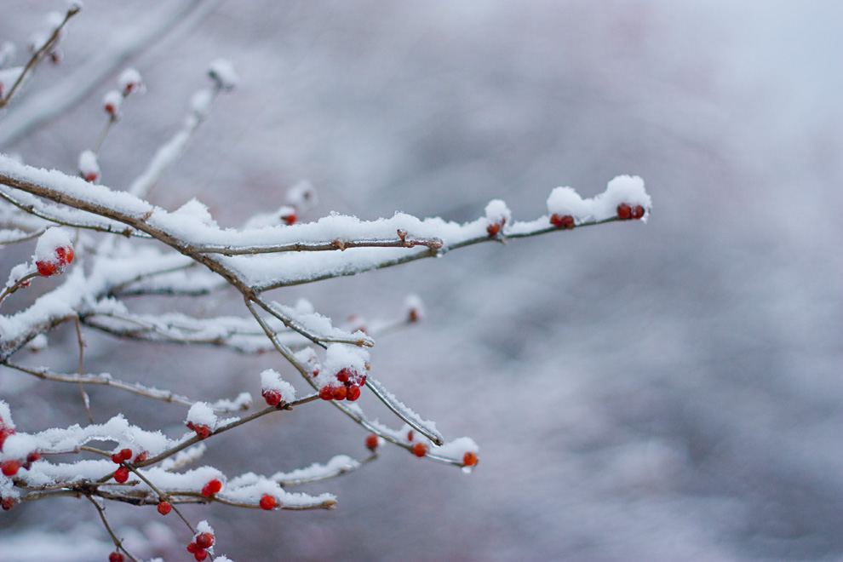

**Eimi Haro**

**Grade Level:** 7 **Current Art Class:** Beginning Art & 3D Art

**First realized she liked art:** “I guess since I was about 4 years old; I used to always draw my family.”

**Favorite piece of artwork she has created:** “I really like the statue of liberty that I am making because I didn’t know that I could do something so well in 3D Art. My favorite part is the torch because the flame looks pretty cool.”

**What has helped her improve her work:** “Mrs. Moser helped me to understand the shaping and the contour lines.”

**Advice for others:** “Do something that you are able to do, but still pushes you.”

**Other hobbies/interests:** “I like to play basketball.”

**Next project she would like to try:** “I want to try shading with pencil because I feel like I’ve tried non-objective and abstract art more than representational art.”

**Emily Gonzalez**

**Grade Level:** Sophomore (10)

**Current Art Class:** Ceramics B

**First realized she liked art:** “I never liked drawing because I can’t, but when I got to High School I saw there was a ceramics class so I thought it would be interesting, so I chose it. Ever since I started the class I really enjoyed it.”

**Favorite kind of art:** “Ceramics.”

**Favorite piece of artwork she has created:** “My Half & Half Pot.”

**Other hobbies/interests:** “Playing volleyball and just hanging out with friends.”

**What she likes most about art:** “Just creating things with clay even though it’s messy, but it’s really fun.”

High School

Junior High

**Porter Hibbert**

**Grade level:** Freshman (9)

**Current art class:** Art 1B

**First realized he liked art:** “In Junior High.”

**Favorite kind of art:** “Mixed Media.”

**Favorite piece of artwork he has created:** “My pencil head drawing.”

**Other hobbies/interests:** “Soccer, skateboarding.”

**What he likes most about art:** “Creating something that looks real.”

**Artists of the Month: JANUARY**

**Camille Wheeler**

**Grade level:** 7

**Current Art Class:** 2D Art

**First realized she liked art:** “As a kid, when I made doodles for my grandmother.”

**Favorite work of art she has created:** “I have lots of favorites, but I like to draw fiction.”

**What has helped her improve her work:** “The 2D Art class has helped me a lot; I am always learning.”

**Advice for others:** “Keep practicing and you get better. Sometimes it takes time and patience, but don’t give up.”

**Other hobbies/interests: “**Reading.”

**Next project she would like to try:** “I was going to work on a shading project of a chess set.”

High School

Junior High

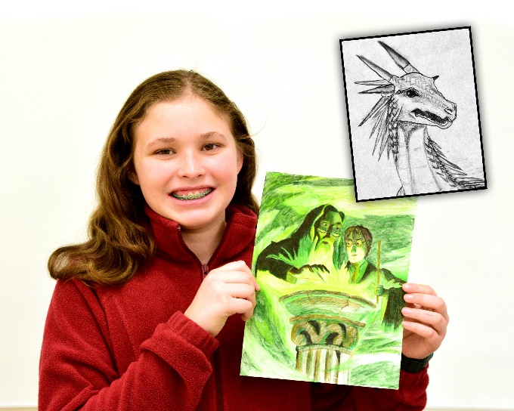

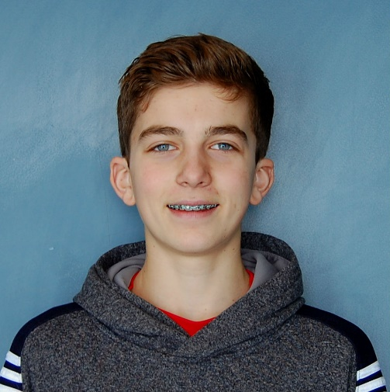

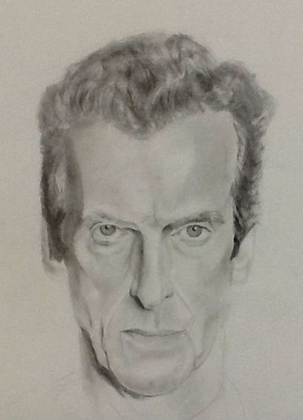

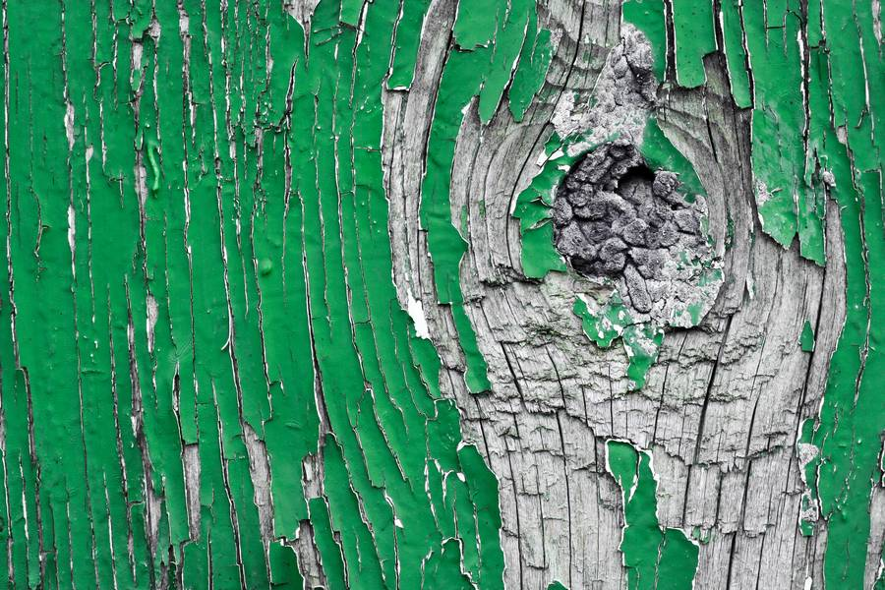

**Artists of the Month: FEBRUARY**

Junior High

High School

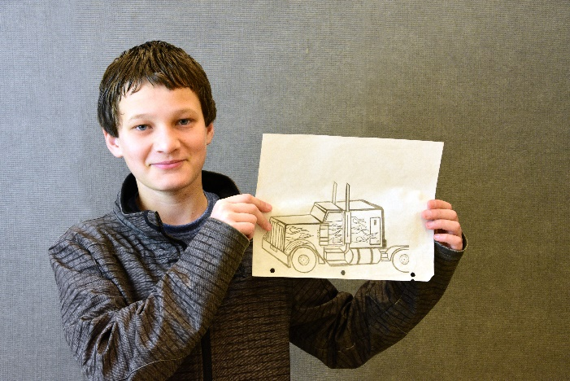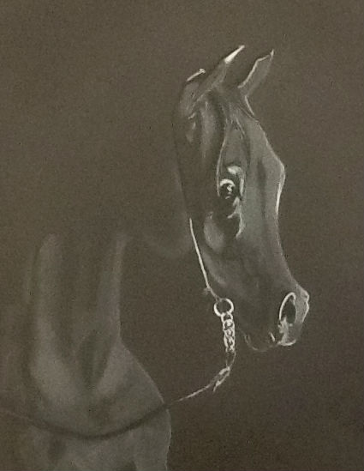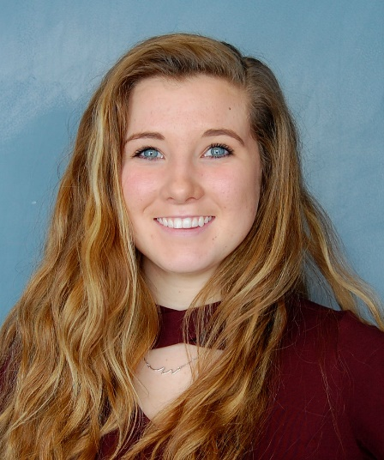

**Hunter Schwendiman**

**Grade level:** 8

**Current Art Class:** 2D Art

**First realized he liked art:** “In Beginning Art class.”

F**avorite work of art he has created: “**My recycled project in 3D Art because it was made of metal and not just any ordinary paper.”

**What has helped him improve his work:** “Knowing how to check my angles.”

**Advice for others:** “Stay Focused!”

**Other hobbies/interests: “**Dirt biking and snowmobiling.”

**Next project he would like to try:** “Painting looks like it would be cool.”

**Chesnee Anderson**

**Grade Level:** Sophomore (10) **Current Art Class:** Art 1B

**First realized she liked art:** “I liked art when I was a young girl, I always loved to color and create what I believed to be a masterpiece. I really got into art in 7th grade.”

**Favorite kind of art:** “I love drawing, but I do like ceramics and photography. I really just love them all, but my favorite would have to be drawing.”

**Favorite piece of artwork she has created:** “If I had to choose it would be my Arabian I did in this class.”

**Other hobbies/interests:** “I love the outdoors and I love to Jet Ski and ride horses. I love anything that keeps me engaged.”

**What she likes most about art:** “I love the creativity in art and how it is your creation not someone else. Makes you relax and enjoy your artwork.”