District Family Night with Hank Smith
Monday, August 20, 2018 7:00-8:00 pm
SSHS —seating limited
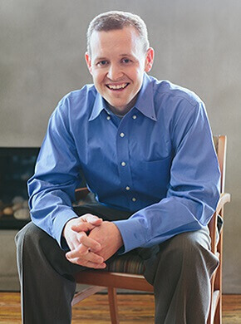
- Dr. Henry “Hank” Smith grew up the son of a golf professional in sunny St. George, Utah.
- After earning a Bachelor’s Degree from Dixie State University, Hank earned a Master’s Degree in Business Administration from Utah State University and finally a PhD from Brigham Young University in Provo, Utah.
- In addition to his corporate training and education consulting, Hank enjoys speaking schools around the country.
- Hank is a bestselling author and has been published in journals and quoted in books around the world.
- His article, “Trust at Ground Zero: Trust and Collaboration within the Professional Learning Community” was recently featured in the bestselling international book, “Trust and School Life.”
- He offers companies and schools research based insights with an entertaining presentation style.
- Hank enjoys running marathons and eating lots of ice cream, which is why he runs marathons. Hank, his wife Sara, and their 5 adorable children currently live in Mapleton, Utah.

District Family Night with Hank Smith
Monday, August 20, 2018 7:00-8:00 pm
SSHS --seating limited
- Dr. Henry “Hank” Smith grew up the son of a golf professional in sunny St. George, Utah.
- After earning a Bachelor’s Degree from Dixie State University, Hank earned a Master’s Degree in Business Administration from Utah State University and finally a PhD from Brigham Young University in Provo, Utah.
- In addition to his corporate training and education consulting, Hank enjoys speaking schools around the country.
- Hank is a bestselling author and has been published in journals and quoted in books around the world.
- His article, “Trust at Ground Zero: Trust and Collaboration within the Professional Learning Community” was recently featured in the bestselling international book, “Trust and School Life.”
- He offers companies and schools research based insights with an entertaining presentation style.
- Hank enjoys running marathons and eating lots of ice cream, which is why he runs marathons. Hank, his wife Sara, and their 5 adorable children currently live in Mapleton, Utah.

